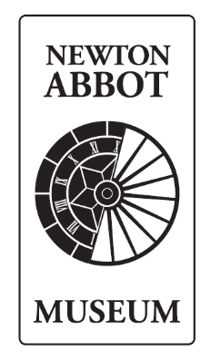

Role Description: Access Focus Group Volunteer

Commitment:
This is a new initiative, it is proposed that the panel will meet four times a year. Meetings may be in-person or hybrid depending on access needs.

Location: Newton Abbot Museum, Newton’s Place, Wolborough Street, Newton Abbot, TQ12 1JQ
Reporting to: Museum Curator

Overview
The Museum tells the stories of local people and the area through exciting displays shaped by community input. With over 17,000 objects in the collection, many unusual and significant items are on display or held in storage.
We are about to embark on a three-year project, funded by the National Lottery Heritage Fund, to build a new museum store. Our current store is not accessible to the public due to narrow corridors and limited space, and some items are stored off-site. This new extension will ensure:
- Step-free, accessible access
- All collections are held in one purpose-built space
- Improved opportunities for public engagement and display
We are forming an Access Focus Group to work with us as we develop this project and improve access across all aspects of the Museum's work.
Our team includes a Curator, two Curatorial Assistants, an Administrative Assistant, a Collections Assistant, and a fantastic group of volunteers. The “What’s in Store?” project team also includes a Project Manager and Community Engagement Officer.

Role Purpose
The panel will bring together the expertise and lived experience of Deaf people, disabled people, and those with relevant lived or professional experience. Members will support us by giving feedback on our projects, buildings, services, and activities. This work will begin with our next major project, What’s in Store?
We are seeking 10 individuals from the local area with lived experience of Deafness, disability, or experience gained through:
- Working or volunteering for a Deaf or Disabled People’s Organisation or charity, or participating in a health- or disability-related network, campaign, or research project
- Supporting someone in their daily life who is Deaf or disabled
Panel members will work with Museum staff and the project team to:
- Offer feedback on projects, spaces, and services
- Help shape access to the new museum store
- Advise on inclusive programming and interpretation
- Share lived experience to support better decision-making
We are committed to ensuring involvement in the panel is accessible, inclusive, and meaningful.

Outline of Responsibilities

Outline of Role Responsibilities:
- Attend Accessibility Focus Group meetings at Newton’s Place. Hybrid participation will be available if required. Meetings will likely take place on Tuesday evenings between 6:00–8:30pm, depending on room availability
- Take part in group discussions, sharing ideas and providing feedback on services, activities, and policy development.
- Optional opportunities may arise to participate in events or feature in content for social media or our website.

Person Specification:
 | Essential | Desirable | Evidence
Enthusiasm for the Museum collections and the Museum’s aims and objectives | ✓ |  | Application form and informal chat
Ability to work with other volunteers, the public | ✓ |  | Application form and informal chat
Practicality and versatility, with the ability to work within a small, dynamic, friendly and committed team | ✓ |  | Application form and informal chat
Communication Skills
Experience of working the public and communicating with people from diverse backgrounds |  | ✓ | Application form and informal chat

If you are interested in the Access Focus Group, please complete a volunteer application form and return to Joanna.eccles@newtonabbot-tc.gov.uk by 4th January.

